Trips Not Made
Addressing transport disadvantage experienced by disabled people and young people in Tasmania’s outer urban and regional communities
Summary Report
Author: Dr Lisa Stafford
Date: March 2023

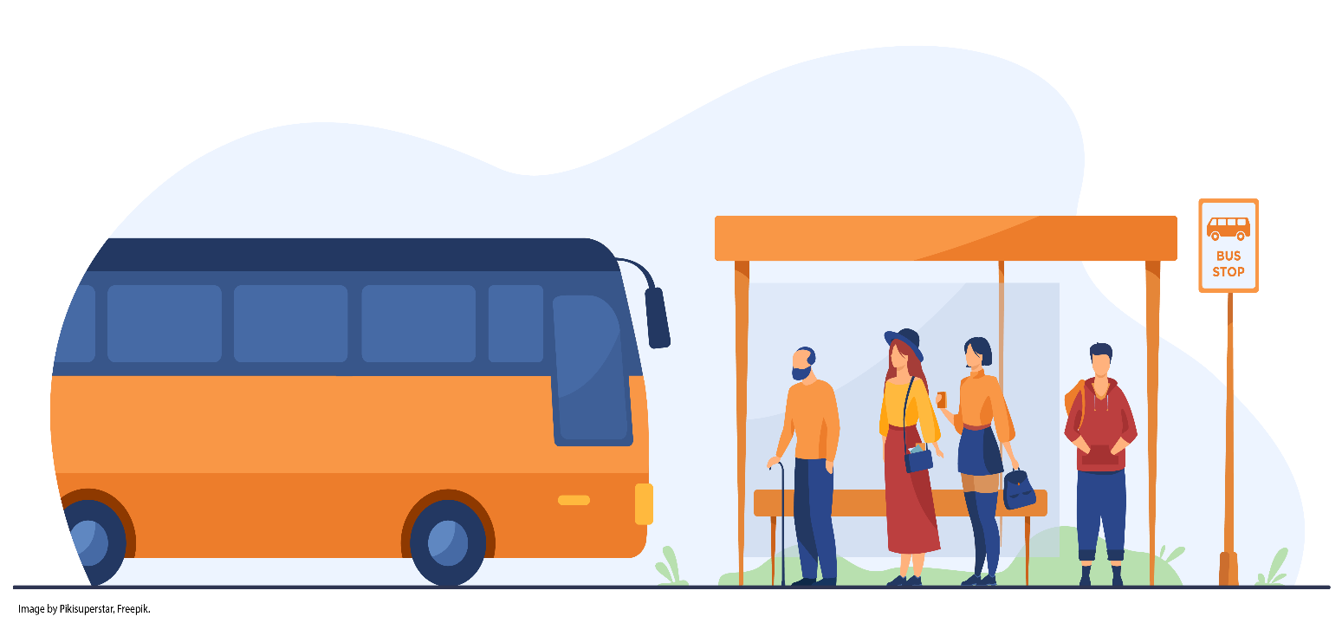

Preferred reference:
Stafford, Lisa. (2023). Trips Not Made: Addressing Transport disadvantage experienced by disabled people and young people in Tasmania’s outer urban and regional communities. (Research short report). Social Action and Research Centre, Anglicare Tasmania.
Contact details:
Dr Lisa Stafford email: lisa.stafford@utas.edu.au or phone 03 6226 2143

Cover Image: Creative Commons - Image by Pikisuperstar, Freepik

Research Ethics: This project has UTAS Ethics Approval - H0024779

Note: Use of language
The term “disabled people” is used in this report in line with social and critical models of disability that recognise that people are disabled by society due to structural, attitudinal and systemic injustice, not through impairments/conditions. However, it is acknowledged that people identify in many ways, and person-first language is often used – “person with disability” – in line with the United Nations Convention on Rights of Persons with Disabilities.

Definitions used in this report:
Public transport (also known as mass transit, passenger transport) connects people and places for fare on regular routes at regular intervals according to a public schedule.
Equity relates to fairness and justice and is distinguished from equality. Equality means providing the same to all; equity means recognising that we do not all start from the same place and making adjustments to address imbalances. This process is ongoing, requiring us to identify and overcome intentional and unintentional barriers arising from bias or systemic structures.

Contents
Acknowledgements 4
Background 5
Summary of key findings 8
The realities of using public transport in Tasmania 8
Common experiences of the bus 8
Communities’ experiences 8
What stops people using public transport? Tension points across the whole of journey experience 9
Trips not being made 10
Changes needed so people can use public transport regularly 12
Recommendations 16
Act now 17
Conclusion 17
References 18

Acknowledgements
Thank you to:
- the participants involved in this research for sharing your experiences about using public transport in Tasmania
- the young people, co-researchers and advisors, Isaac Tye and Haru Fergus for their insights and commitment to public transport equity, and Isabella and Joe who contributed to the project’s development
- key industry and community advisors Katie Cooper (Metro Tasmania), Martin Crane and Todd Newett (Department of State Growth), Charlie Burton (TasCOSS), Andrew Holmes (Planning Institute of Australia and Transport Australia Society), Lynden Leppard (Local Government Association Tasmania) and Jason Byrne (University of Tasmania)
- Anglicare Tasmania for funding and supporting this project.

Anglicare Tasmania acknowledges the Tasmanian Aboriginal community as the traditional and original owners and continuing custodians of this land lutruwita. We pay respect to Elders past and present.

Background
Public transport matters. It is an essential service in modern society.
Public transport:
- is a key enabler of social and economic participation (ITF 2020; Infrastructure Australia 2019, 2018b)
- a key social determinant of health (WHO 2011)
- helps tackle broader social and environmental injustices like climate change and poverty
- is a necessity for people with disabilities to participate fully in all aspects of life (United Nations Convention on the Rights of Persons with Disabilities, Article 9).
Transport equity is a key target of the UN Sustainable Development Goals (SDGs) (11.2). By 2030, the goal for all countries and cities is to provide access to safe, affordable, accessible and sustainable transport systems for all, notably by expanding public transport, with special attention to the needs of those in vulnerable situations, women, children, people with disabilities and older people (United Nations n.d.).
Inclusive thinking and equity adjustments must be embedded in the public transport system to ensure fair and just access and usage for all users/passengers (Doran et al. 2022). However, public transport in Tasmania is not currently equitable and accessible. There is significant transport disadvantage.
Transport disadvantage is having no or limited public transport where you live to access everyday services and participate in everyday activities (like work, school, appointments), and no way to ease this barrier without adverse consequences such as further financial stress or safety risks (Jeekel 2019). People with disabilities, young people, older people, low-income earners and people in outer suburbs and urban fringe areas commonly experience barriers to transport.
Tasmania has the highest per capita number of people with disabilities and long-term health conditions in Australia.
- 1 in 4 (26.8%) Tasmanians have disability (ABS 2018)
- 1 in 3 (37.5%) Tasmanians have long term health conditions (ABS n.d.).
Tasmanians lack access to public transport. According to the Bureau of Infrastructure and Transport Research Economics, only:
- 13.5% of households in Hobart have access to public transport (worst of all capital cities in Australia)
- 5% of households in Launceston have access to public transport (least accessible compared to all other states, territories, and regional cities in Australia) (BITRE n.d.) (see Figure 1).
Tasmania, like all other states and territories, is required to have 100% of its bus stops in compliance with the Disability Standards for Accessible Public Transport (2002) by the end of 2022 (Department of Infrastructure, Transport, Regional Development, Communications and the Arts n.d.). Despite having had 20 years to work on this requirement, Tasmania will not be able to fulfil its responsibility. According to the 2019 Australian Infrastructure Audit, only 37.5% of bus stops were compliant in Tasmania (Infrastructure Australia 2019). In 2022, the Tasmanian State Government committed $10 million over four years for bus stop upgrades (Department of State Growth n.d.).

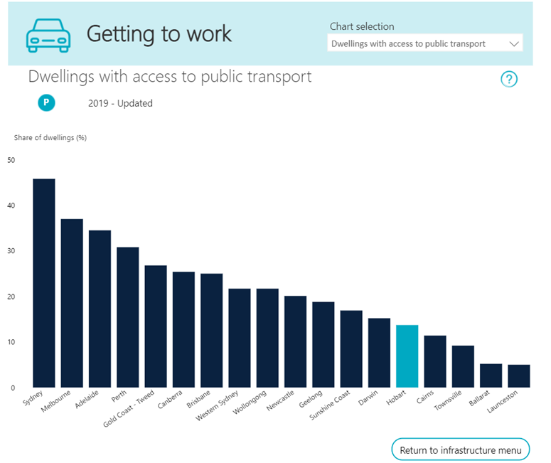

Figure 1. Dwellings with access to public transport. Source: BITRE National cities performance framework

At the same time, Tasmania has the lowest investment in passenger transport compared to any other Australian state or territory, with only $221.36 per person spent on passenger transport in Tasmania in 2019-20. The next lowest expenditure is the Northern Territory at $254.92 per capita (TasCOSS, 2019).
Poor public transport usage in Tasmania is often cited as a reason for weak investment, but little is known about the barriers to actual usage – the trips not being made, and why.
This research asks these questions and gives voice to communities and people (young people and people who identify as having disability, neurodiversity and mental health needs) who experience public transport disadvantage.
The aim of the study is to:
- understand the realities of trying to use public transport in Tasmania
- know what trips are not being made due to barriers across the whole journey
- identify what is needed so people can use public transport more regularly in the future.

Summary of key findings
Forty-five participants shared their experiences of using public transport in Tasmania. 53% were young people, 66% were disabled people, and 44% identified as both disabled and a young person.
Participants were from across the state: 25% North West, 15% North/Northeast, 40% South East, 20% South/South West.
People shared their experiences in either community chats (world café style focus groups) or an individual interview based around the same set of questions. For over half the participants, the bus was their only source of transport as they didn’t or couldn’t drive. Others had no easy access to a bus and had to rely on other means, and some had given up on the bus due to negative experiences.

The realities of using public transport in Tasmania
The bus is the main mode of passenger transport in Tasmania. A ferry trial between Bellerive (inner suburb on eastern shore) and Hobart’s CBD was introduced in 2021, but no participants in this study used this service as a regular means of transport.

Common experiences of the bus
The research identified a range of barriers experienced by people across the whole of journey. Many described public transport as:
- untrustworthy – not dependable, worrying and risky
- costly – in money, time, dignity, income and safety
- limiting their choices and opportunities.
“That’s a real fear here, you don’t know if the bus is coming or not … they get cancelled so often.” (Young person)
“So when I finish my degree, I have no idea how I’m going to get work because of the public transport.” (Disabled person)
Participants did speak favourably of the provision of free bus services, including the initiative that ran between 28 March to 30 April 2022, which according to the CEO of Metro saw a significant increase in patronage (Podwinski 2022).

Communities’ experiences
South East (Brighton, Primrose Sands) and North West (Burnie, Ulverstone, Devonport) communities described access disparity that was supported by policy review and route mapping. Disparities of costs and timetabling occurred between inner urban and outer suburbs, and between Metro-and non-Metro service providers.
“And this man said ‘One day though I was a bit disappointed in the bus service, I had to wait 25 minutes for a bus to come’. He lived in X [inner city]. And I thought, ‘oh mate if my child misses a bus he has to wait three hours in some instances’...” (South East resident)
Deep connections exist between housing affordability issues and access to public transport.
“I do live in a slightly outer-lying area …. As much as I would love to be right near public transport, let’s have a look at the housing situation in rental… that’s not going to happen any time soon.” (Young person)
Participants said the public transport system upholds disadvantage. For people outside cities, public transport costs more, there are fewer services, reliability and availability is poor, and travel times are longer.

What stops people using public transport? Tension points across the whole of journey experience
- Difficulties planning the trip
  - Confusing and poor access to information and technology. Participants described timetables that were difficult to read and use, inadequate apps, no real time information, difficulty planning multi-route trips with the existing planning tools, lack of accessibility of certain formats of timetables and missing or out of date timetables at bus stops.
  - Disconnection and complexity of making a trip. Participants said they often had to catch multiple buses with long wait times in between. Route times were largely based on services for 9AM-5PM commuters and lacked responsiveness to the needs of diverse users.
- Difficulties getting to the bus. Participants described unsafe surfaces, seasonal weather conditions such as black ice, poor lighting, long distances and poor infrastructure as barriers to getting to the bus stop.
- Nervous or uncomfortable waits for the bus due to the lack of real time information, a history of buses not turning up or missing the bus, feeling unsafe, and uncomfortable waiting environments without shelters, seats or lighting.
- Having to be vigilant on the bus. This experience related to delays in online top up (24/48-hour delay) which left people without credit, negative bus driver-passenger interactions, crowding, personal safety (sexual harassment, bullying), inconsistent onboard lighting, limited security, and not knowing where to get off due to lack of real time or visual and auditory prompts.
- Getting stuck getting home was a common experience amongst participants. This occurred because of limited services, lack of real-time information and the unpredictability of services.
“It’s an appalling online system for Tassie. It’s like so complicated, so confusing… an app would be great with the updates where the bus is.” (Disabled young person)
“I wouldn’t actually catch a bus going to uni because I’d have to catch four buses. So, by the time I managed to do that, it’d take a long time, I don’t think I’d be able to manage it physically. There’d also be quite a bit of walking.” (Disabled person)
Due to tenuous and at times unsafe experiences, many people used public transport as a last resort. People described feeling pushed to get a licence and car (if they were eligible to drive) because of the systemic barriers to using public transport.
“I don’t want to get a car, because it costs so much more and getting the licence costs a lot and fuel costs so much and it’s not economical for me as a student to get a car.” (Disabled young person)

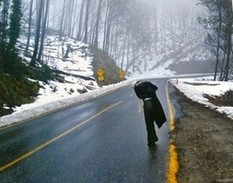
Figure 2. “I like this picture because that’s what it feels like standing at a bus stop in Tasmania. No shelter, cold, wet and unsafe.” (North West resident) (Image from Innovative Resources’ Picture this card pack, which was used in community chats.)

Trips not being made
“I have mentally cancelled a lot of trips.” (Disabled young person)
Systemic social and physical access barriers to public transport meant many participants were not taking trips. These included trips to:
- work
- see friends and family
- health appointments
- go out at night or weekends.
Trips not made affected people in various ways and across multiple life domains. As most participants didn’t or couldn’t drive, and many lived in outer urban or urban fringe areas with limited service availability, many described a feeling of being unable to “do anything”.
“And that’s really socially isolating so, really, this can disengage us as well… certainly right at the top of the list as the major disadvantage is getting around. It’s really, really difficult to get around.“ (Disabled person)
“I had to deny night shift. Because I couldn’t go back home… I was like sorry guys I can’t work those days, because I physically can’t do a night shift.” (Disabled young person)
“It’s just like public transport is so the public can... transport [laughter] but there’s nothing to transport on. You can’t do anything.” (Disabled young person)
“What you were saying, all the appointments, medical appointments, the shopping, if you had animals. You know unless you have someone who can take you, you can’t go.” (Disabled person)
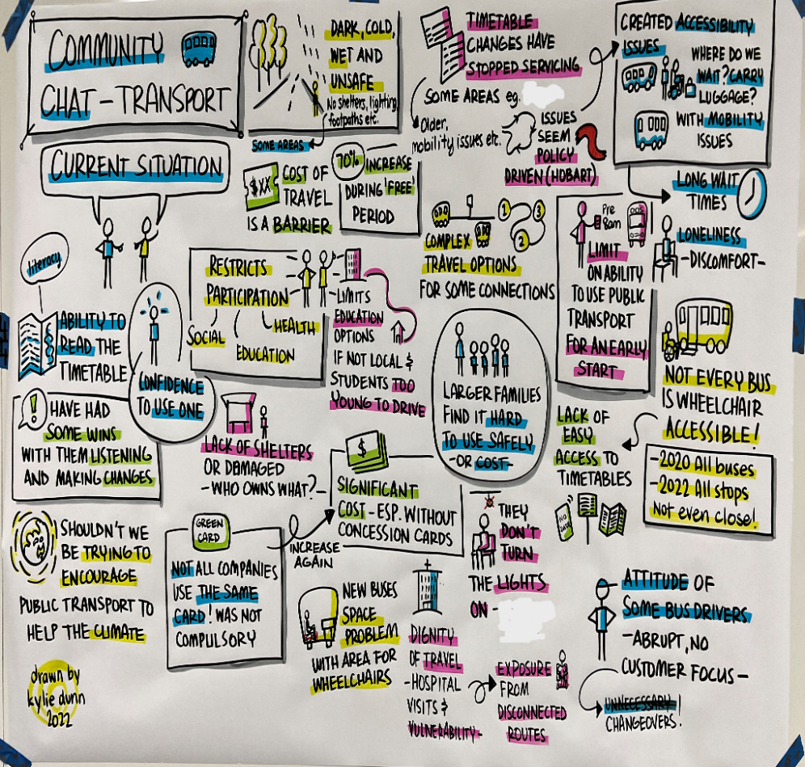
Figure 3. Current experiences using public transport, captured in a visual recording of a North West community chat. (Drawn by Kylie Dunn – Dinkylune)

Changes needed so people can use public transport regularly
Participants shared a variety of ideas for reducing barriers to using public transport and ensuring they could access it more regularly and with less stress and difficulty. These ideas are grouped around key points in the whole of journey and include strategic structural level changes. These ideas are presented in Table 1.
- Build trust in public transport by having a system that is easy to use, fully accessible, affordable and responsive to the diverse needs of users.
“Well, I mean I wouldn’t want it to be really less frequent, but if it didn’t get more frequent but got more reliable I feel like that would make it a lot better in my mind, because the combination of not frequent and unreliable was really stressful...” (Disabled young person)
Trust is enabled by providing inclusive network services and infrastructure to give people confidence in using public transport. Some key areas for improvement include:
- digital access – such as live updates (real time information) with text to talk, notification alerts, QR codes, non-data metered access, and integrated and contemporary payment options
- built access – walkable, safe, accessible paths and all-weather bus shelters
- bus upgrades – accessible, step-free kneeling buses with automatic ramps, visual and auditory cues, digital screens, phone chargers, lighting and wifi.
“But just like how it was with Translink [QLD System], you put in your destination, it tells you how many minutes away the bus is. And you either get your ass down to the bus stop or you wait another 20 minutes, however that may be. But easy apps are definitely something that contributes to wanting to catch the bus…” (Disabled young person)
“Close the gap for young people. …it doesn’t have to be very, very often, but buses that go from late at night to early in the morning because some people have night shifts.” (Disabled young person)
Participants also wanted improved customer service. This included having a feedback option accessible and available at all times through a QR code on the bus, and providing service information through a variety of communication channels.

- Plan with people and communities. This includes having integrated community level transport strategies and implementation plans that:
- Explore options such as trialling on-demand services.
- Develop stronger partnerships and better utilisation of resources in communities.
- Learn from initiatives elsewhere.
“Put it to the people who actually use the service. … It probably looks alright on paper to a certain subset of people. Or the people who are organising, it probably looks great. But then in reality and trying to mesh that into the different services between different areas down here, and then actually trying to fit that into your life and for it to be convenient for you, it’s a bit of a job itself really. So I think definitely putting it back to the community, because we’re the users of the service.” (Disabled person)

- Bring an equity focus to network and strategic planning.
Research participants felt that equity must be taken seriously as a core planning and decision-making principle. Doing so upholds human rights and, importantly, opens opportunities for participation, independence and freedom, while benefiting the social health and economy of people and communities.
“I think you’ll find that, especially people with disabilities … that we want to have our independence. We want to be able to do those kinds of things and not be not allowed to do them for things that are beyond our control.” (Disabled person)

- Change the story and culture about public transport to better promote its benefits.
Participants felt that changing attitudes started with governments improving the system and thus rebuilding trust. People said public transport should be positioned as a core asset, with clear returns on investment in terms of economic and social participation, and individual and community health and wellbeing.
“I think that’s a model of what we need … that transport makes a complete life possible… these sort of services become almost like a lifeline to a community. And you’ve got to be able to do the things that a community needs. I believe that what I want from a service is something that makes the community better and makes the community more liveable.” (Disabled young person)

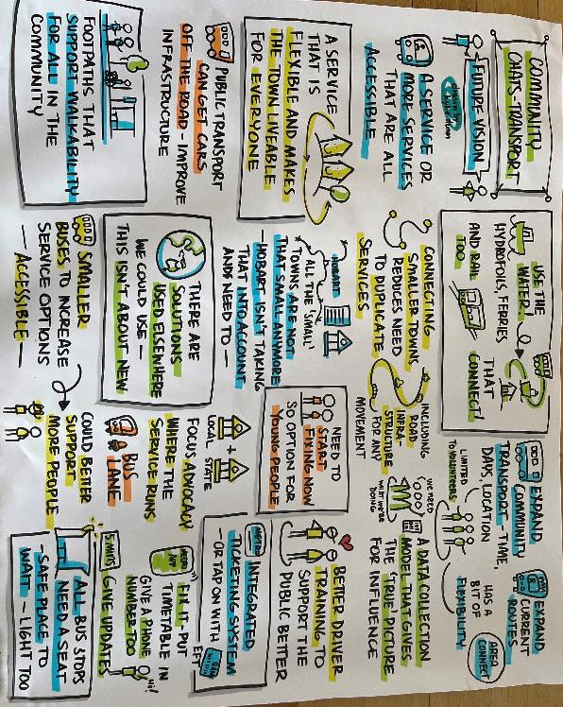
Figure 4. Future vision, captured in a visual recording of a South East community chat. (Drawn by Kylie Dunn – Dinkylune)

Table 1: Barriers across whole of journey with possible change/solution to enhance public transport usage
Problems | Possible solutions
Limited trip planning with inadequate technology | Seamless trip planning  - Up to date technology, real time information, cross-provider app, integrated trip planning, digital inclusion/accessible features  - Easy to print to take with you to aid navigation
Complicated timetables | User-friendly timetable information  - Information in formats suitable for all learning needs  - Compliant with top level of web accessibility  - Inclusive features like Text to Talk  - Located on unmetered website to ensure equity  - QR code timetables at bus stop
Disconnected and unavailable times and routes | Seamless networks  - Routes and service availability connect and support people to travel effortlessly within one’s region. Region definitions as per ABS.  - Both main route and feeder services – not either/or  - Integrate with other forms like on-demand and community transport for outer suburb and rural-regional areas with consistency in price
Costly inconsistent pricing | Affordable and just fares  - Fair and consistent pricing across all providers and modes  - Ensure low-income working people can access fair concessions (Productivity Commission 2021)  - Ensure fair pricing for outer suburb areas (Infrastructure Australia 2018a; Productivity Commission 2021)  - Auto top-up on card  - Travel any time all day with maximum ceiling
Non-walkable bus stops | Easy to reach bus stops  - Provision of walkable/rideable/wheelable/pushable infrastructure connecting to bus stops  - Sealed safe surface suitable in all seasons particularly black ice/rain in winter  - Walkable distance 400m – 10 mins preferred
Nervous waiting at bus stop | Accessible, all-weather safe shelters  - Shelters with seating and wheelchair space, protection from rain/wind/sleet/snow, kerb/pram ramps, lighting, good sightlines, security surveillance.  - Supported with real time information, QR code timetables and emergency mobile signal
Having to be vigilant on the bus | Stress-free bus journey  - Bus accessibility: kneeing with auto ramps, audio and visual bus stop announcements, lighting for safety  - QR code customer service for immediate feedback, improved security for passengers and drivers (e.g. live camera or security), more buses to limit crowding, consistent cross-provider policies about lighting  - On the go trip planning  - Bike or mobility aid storage  - Driver disability diversity education
Getting stuck getting home | Stress-free Bus Journey Home (as above) plus:  - A variety of service times and mode options  - Plan with people and communities impacted by transport disadvantage to address gaps

Recommendations
This project recommends a trustworthy system that is easy to use, accessible, affordable and responsive to a diversity of users. This will build equity and close the barriers that currently create transport disadvantage in Tasmania.
- Recommendation 1: A major increase in investment to provide a public transport system that promotes and strengthens social and economic participation, health equity and climate justice in Tasmania, while reducing congestion.
  - As a starting point, the Tasmanian Government can prioritise and lift investment in public transport to reflect that of other states in Australia.
  - Think “big picture”. Prepare a universally designed integrated public and active transport and land-use plan for small cities and regional centres that serves all people, communities, business and environment.
  - Think in terms of return on investment including social, environmental, health and economic impacts.
- Recommendation 2: Institutional and diverse user collaboration with central coordination to ensure an integrated system with the right transport services and choices for all current and future users.
  - Core central oversight and integrated systems across Tasmania, regardless of provider or mode.
  - Plan with diverse users and communities with transport disadvantage to determine the best fit for purpose services and infrastructures to ensure all-inclusive accessibility for a seamless whole of journey experience.
- Recommendation 3: A seamless network to ensure everyone can make complete and connected journeys that are fully accessible from origin to destination and return, day and night, to support diverse users and activities.
- Recommendation 4: User-friendly inclusive information and technology so all users can make informed decisions before and during their journey through legible formats and latest technology like real time planning. Ensure major current improvements projects like central ticketing prioritise equity and inclusion features.
- Recommendation 5: Equitable fares and seamless payments to ensure users are not penalised for where they live and for making the most use of public transport. This would include an integrated transport payment system for Tasmania with automatic top-up, a variety of payment methods and consistent fares.
- Recommendation 6: Easily reached, accessible and safe bus stops to ensure all users can enjoy the most inclusive, accessible travel experience. This includes provision of:
- main trunk routes with park and ride
- feeder routes with inclusive safe bus stops and seamless connections
- on-demand services and community transport providing door-to-door services
- a final ruling /resolution on responsibility for bus stop infrastructure
- ongoing capital works program for active and public transport infrastructure, particularly for outer suburbs, to close gaps on transport disadvantage.
- Recommendation 7: Integrate transport and land use planning with infrastructure plans in Tasmania. This would ensure public transport equity is embedded in all key economic and social developments, particularly new housing. Opportunities include Tasmanian planning policies and other mechanisms like the renewal of regional plans.
- Recommendation 8: Introduce mandatory reporting on public transport equity indicators and measures. This would monitor progress using at a minimum the Australian Disability Strategy and SDG 11.2 outcome measures.

Act now
Participants felt there were things that could be done immediately that would help to improve accessibility. They wanted to see urgent action on elements such as:
- a consistent policy for lighting on buses
- using the research to inform current projects like ticketing and improved accessibility of bus stops
- improving the legibility and availability of clear information.

Conclusion
The lived experiences shared in this research provide important insights about what it is like to access and use public transport in Tasmania as a young person and/or disabled person and/or while living in outer suburbs and regional centres. The multitude of barriers reveal many points of tension that stop people using public transport. While not generalisable, this study is a comprehensive descriptive study of a relatively unstudied issue.
The solutions and recommendations emerging from this research offer a pathway to the provision of a modern service that meets the needs of diverse users. They align with current recommendations from national public transport strategies and Infrastructure Australia and help to meet Tasmania to enact its social and economic policies and fulfil its responsibilities under national legislation and international agreements. They also build on initiatives already in progress such as integrated ticketing and bus stop accessibility.
Inclusive public transport is a critical investment. By strengthening the system and improving equity in access and connectivity across the journey, the state’s public transport can be made more sustainable, future-proof and inclusive.

References
Australian Bureau of Statistics (ABS) n.d., Tasmania 2021 Census all persons QuickStats, viewed March 2023, https://www.abs.gov.au/census/find-census-data/quickstats/2021/6.
— 2018, Disability, ageing and carers, Australia: Summary of findings, viewed March 2023, https://www.abs.gov.au/statistics/health/disability/disability-ageing-and-carers-australia-summary-findings/latest-release.
Bureau of Infrastructure and Transport Research Economics (BITRE) n.d., National cities performance framework, viewed March 2023, https://www.bitre.gov.au/publications/2021/review-national-cities-performance-framework-final-paper.
Department of Infrastructure, Transport, Regional Development, Communications and the Arts n.d., Transport accessibility, viewed March 2023, https://www.infrastructure.gov.au/infrastructure-transport-vehicles/transport-accessibility.
Department of State Growth n.d., Bus stop upgrade program, viewed March 2023, https://www.transport.tas.gov.au/public_transport/bus_stop_upgrade_program.
Doran, B, Crossland, K, Brown, P, & Stafford, L 2022, Transport experiences of disabled people in Aotearoa New Zealand, Waka Kotahi NZ Transport Agency research report 690, New Zealand Government, Wellington.
Infrastructure Australia 2019, Australian Infrastructure Audit: Transport, viewed March 2023, https://www.infrastructureaustralia.gov.au/publications/australian-infrastructure-audit-2019.
— 2018a, Outer urban public transport: Improving accessibility in lower-density areas, viewed March 2023, https://www.infrastructureaustralia.gov.au/publications/outer-urban-public-transport-improving-accessibility-lower-density-areas.
— 2018b, Future cities: Planning for our growing population, viewed March 2023, https://www.infrastructureaustralia.gov.au/publications/future-cities-planning-our-growing-population.
International Transport Forum (ITF) 2020, Reforming public transport planning and delivery, ITF Research Reports, OECD Publishing, Paris.
Jeekel, H (ed.) 2019, Inclusive transport: Fighting involuntary transport disadvantages, Elsevier.
Podwinski, I 2022, “Tasmania’s free public buses deemed a success, despite hundreds of route cancellations and driver shortages”, ABCNews, 29 April, viewed March 2023, https://www.abc.net.au/news/2022-04-29/free-tasmanian-bus-service-set-to-end-on-the-weekend/101024014.
Productivity Commission 2021, Public transport pricing, viewed March 2023, https://www.pc.gov.au/research/completed/public-transport.
TasCOSS. (2019). TasCOSS internal policy brief, June 2019 as cited in Greater Hobart Strategic Partnership, State Budget Submission 2020-21, viewed March 2023, https://www.hobartcity.com.au/files/assets/public/projects/greater-hobart-strategic-partnership/greater-hobart-strategic-partnership-state-budget-submission-20-21.pdf

United Nations n.d., Sustainable development goals, website, viewed March 2023, https://www.un.org/sustainabledevelopment/
United Nations Convention on the Rights of Persons with Disabilities, 30 March 2007, viewed March 2023, https://www.un.org/development/desa/disabilities/convention-on-the-rights-of-persons-with-disabilities.html.
World Health Organization (WHO) 2011, Transport (road transport): Shared interests in sustainable outcomes, Social determinants of health sectoral briefing series 3, WHO, Geneva.

BITRE’s Access to Public Transport indicator measures the proportion of dwellings within 400 metres of a public transport stop with a service every 30 minutes from 7am to 7pm on a normal weekday.
A kneeling bus is a bus that not only has no steps between the door and the bus floor, but also has an air-adjustable suspension.

